WSA - HW – 11 :

- Describe the idea of WDS multicast transmission. Provide details and different configuration options.

Windows Deployment Services is the updated and redesigned version of Remote Installation Services (RIS). Windows Deployment Services enables you to deploy Windows operating systems over the network, which means that you do not have to install each operating system directly from a CD or DVD.
Multicasting. Provides the ability to transmit install images using multicasting. This includes the ability to automatically disconnect slow clients and the ability to transfer images using multiple streams of varying speeds. To locate these settings, right-click the server in the MMC snap-in, click Properties, and click the Multicast tab.

Installing WDS:

You can install Windows Deployment Services by using the Initial Configuration Wizard, Server Manager, or the command line.
- To install the role by using the Initial Configuration Wizard, click Add roles on the Initial Configuration Tasks startup screen. Click Next and then select Windows Deployment Services.
- To install the role by using Server Manager, click Add roles, which is located in the Roles Summary pane. Click Next and then select Windows Deployment Services.
- To install the role by using the command line, run one of the following two commands:
  - For Deployment Server, run ServerManagerCmd -install WDS.
  - For Transport Server, run ServerManagerCmd -install WDS-Transport.

Configure WDS:

- Ensure that you are a Domain Administrator.
- Click Start, click Administrative Tools, and then click Windows Deployment Services. If there is not a server listed under the Servers node, right-click the Servers node and click Add Server to add the local computer.
- In the left pane of the Windows Deployment Services MMC snap-in, expand the list of servers.
- Right-click the server, and then click Configure Server (Note that the screenshots included in this document are from Windows Server 2008).

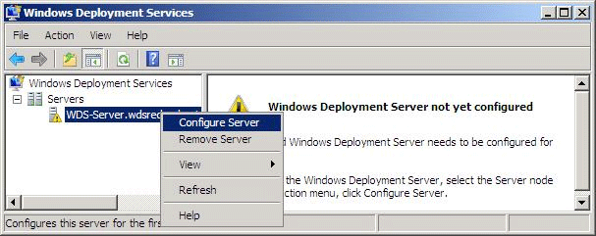

- Follow the instructions in the wizard.
- When the configuration is completed clear the Add images to Windows Deployment Services now check box and then click Finish.

In order to deploy an image using multicasting instead of unicasting, you must first create a multicast transmission. Multicast transmissions make the image available for multicasting, which enables you to deploy an image to a large number of client computers without overburdening the network. When you deploy an image using multicasting, the image is sent over the network only once, which can drastically reduce the amount of network bandwidth that is used. Note that data is transferred only if clients request data. If no clients are connected (that is, if the transmission is idle), data will not be sent over the network. Note that this topic pertains only to the default installation of Windows Deployment Services.

Configure transmissions:
After a transmission has been created, you can perform the following actions:
- Start the transmission. If the transmission is the Scheduled-Cast type, there is at least one client, and the transmission has not started yet, you can right-click the transmission and then click Start. Alternatively, you can run WDSUTIL /Start-MulticastTransmission /Image:<image name> /ImageType:Install /ImageGroup:<image group name>.
- Delete the transmission. If you right-click the transmission and click Delete, the multicast transmission stops and each client installation will start the transmission again using unicasting. That is, the client installations will not be deleted completely, but they will not use the multicast transmission to complete the installation. Alternatively, you can run WDSUTIL /Remove-MulticastTransmission /Image:<image name> /ImageType:Install /ImageGroup:<image group name> /Force.
- Deactivate the transmission. If you right-click and then click Deactivate, each client that is currently installing will continue, but no new clients will be joined to the transmission. After each current client installation is completed, the transmission will be deleted. If there are no clients when you click this option, the transmission will be deleted instantly. Altnernatively you can run WDSUTIL /Remove-MulticastTransmission /Image:<image name> /ImageType:Install /ImageGroup:<image group name>.
- View the transmission's properties. To view the properties, right-click the transmission and then click Properties. Note that you cannot edit the properties of a transmission after it is created. To make a change after you have created a transmission, you need to delete it and then recreate it. Alternatively, you can run WDSUTIL /Get-MulticastTransmission /Image:<image name> /ImageType:Install /ImageGroup:<image group name>.
- Refresh the transmissions and data. To do this, right-click a transmission and then click Refresh. You can also refresh the data by pressing F5.

more info @ :
http://technet.microsoft.com/en-us/library/cc732477.aspx
http://technet.microsoft.com/en-us/library/dd637994%28v=ws.10%29.aspx
http://technet.microsoft.com/en-us/library/7d837d88-6d8e-420c-b68f-a5b4baeb5248.aspx
http://technet.microsoft.com/en-us/library/dd637994%28v=ws.10%29.aspx
http://technet.microsoft.com/en-us/library/cc771060.aspx

